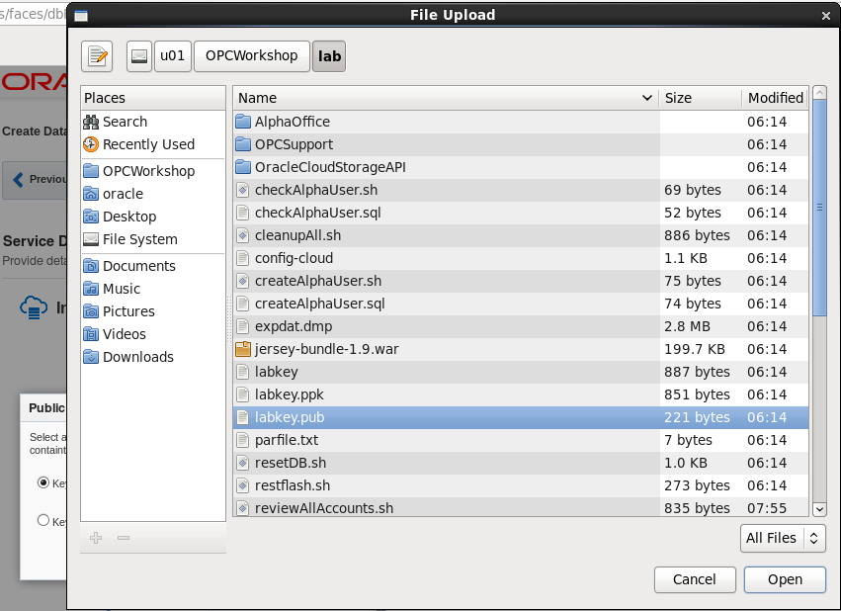

* Click Open and confirm that labkey.pub is shown on the screen

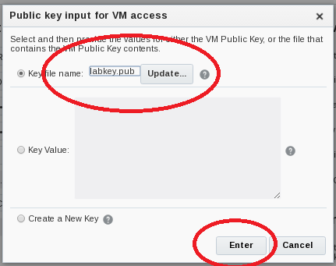

* Click **Enter** and continue filling out the Details form. Continue on to the **Backup and Recovery** and **Initialize Data From Backup Configuration** Sections

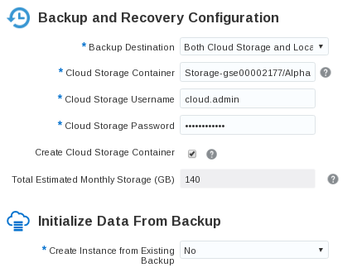

* Use the information from the following table to help fill out the **Backup and Recovery Configuration** and **Initialize Data From Backup** sections.

|  |  |
| --- | --- |
| **Backup and Recovery Configuration Information** | |
| **Backup Destination** | Both Cloud and Local Storage |
| **Cloud Storage Container** | Storage-<your domain name>/Alpha01B_DBCS_SC |
| **Cloud Storage Username** | cloud.admin |
| **Cloud Storage Password** | Use <cloud.admin> assigned password |
| **Create Cloud Storage Container** | Check box – Yes |
| **Total Estimated Monthly Storage (GB)** | Default 140 |
| **Create Instance from Existing Backup** | No |

**Note**: By checking the box labeled - **Create Cloud Storage Container**, if the container does not exist it will be created automatically. This will be the location for all backups

* Confirm the following information from the **Advanced Settings** section. This information is default and doesn’t need to be altered.

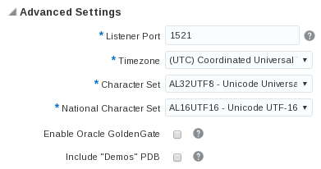

* After all fields have been filled out , click on Next

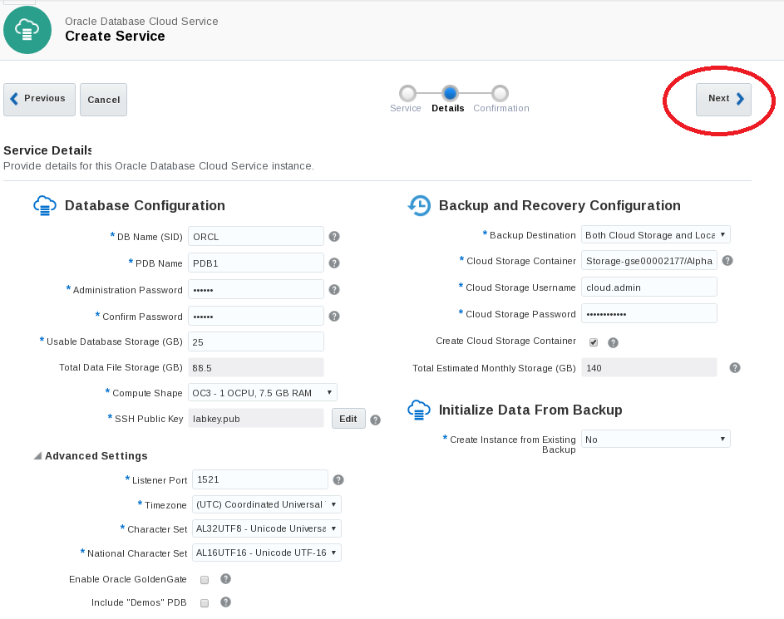

* Review the Confirmation screen and confirm that your entries are correct. When you’re satisfied that everything is in order click Create.

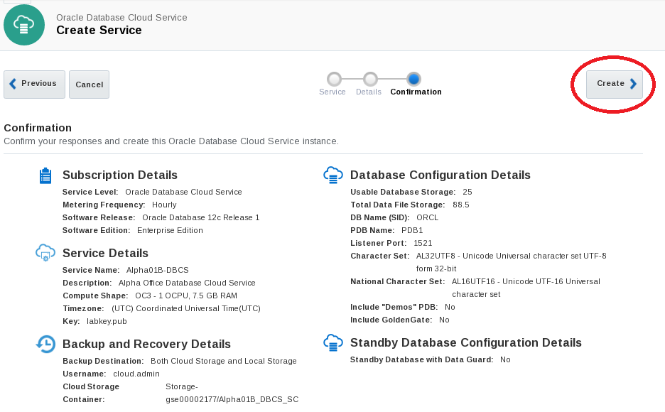

* You should be returned to the dashboard and your new Database Cloud Service instance Alpha01B-DBCS should be visible and labeled as ‘In Progress’

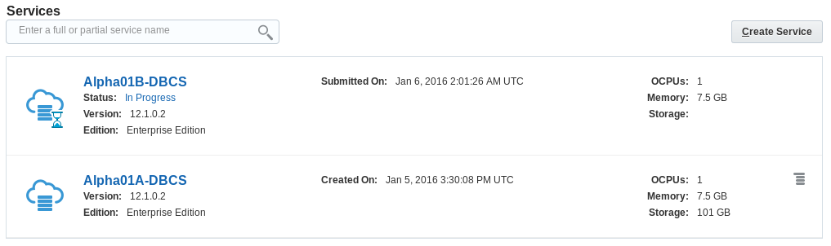

* The creation of the DBCS instance will take approximately 20 minutes. While your DBCS instance is being created, you can view the current status clicking on the In Progress link.

**NOTE**: To save time we will continue with the lab by utilizing Alpha01A-DBCS DBCS instance already created. Alpha01A-DBCS was created following the exact steps you just performed.

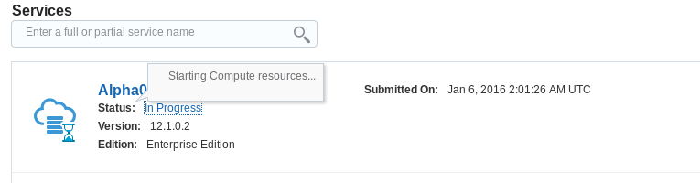

### Configuration and Image Exploration

#### Record the IP address of the Database Cloud Service

In the following steps you will record the IP addresses of the Virtual Machine on which the cloud service runs and configure SSH connectivity to Alpha01A-DBCS. Then you will access the different monitoring, configuration, and development consoles available on Oracle Database Cloud Service.

* Click on Alpha01A-DBCS link or cloud icon from the list of Database Instances to get further details on Alpha01A-DBCS



* Note the Public IP address of Alpha01A-DBCS. In the below example the address is 140.86.12.71, yours will be different.

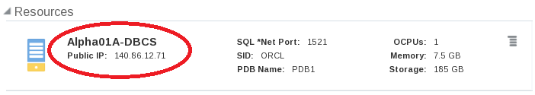

#### Create the SSH configuration file and start tunnels

For obvious reasons the default Oracle Public Cloud network configuration is very secure. Customers can open individual ports to the various servers in the cloud environment through the Compute Cloud Service Console or they can create SSH tunnels to the specific server/port combinations as needed.

In this section we will use **SSH Tunnels** to communicate securely between the client and the Cloud Database instance. We have built a *script that automatically creates these tunnels for you.* You will review the script later in the exercise so you can learn how to create them on your own.

We will show you how to use secure tunnels as well as how to open ports for the following exercises.

In step 1.6.2 you will run the script that creates and configures an SSH file that will be used to connect to your various servers. Once the SSH file is created, it is used as a script to create the SSH tunnels in the background with connections to selected ports used in this and other labs.

* Open a terminal Window using the Utilities menu or by clicking the terminal icon. 
* Change into the lab directory cd lab
* Run the SSH script to open the ports. Type ./setssh.sh DBONLY in the terminal window

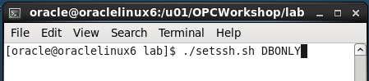

* If you make an error you’ll see:

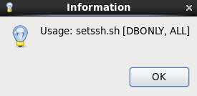

* Enter the Cloud Database IP address obtained in Step 1.6.1 and. Click OK.

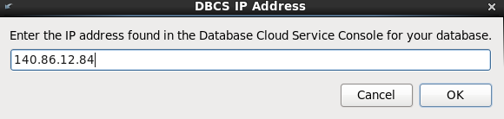

The script will try a test connection to your server. If successful, an SSH configuration file is created and an SSH session to the DB server will be started in the background.

If the script encounters any problems, or you entered the wrong address, you will be re-prompted to enter the IP address.

If the tunnels are created successfully you will see a Success Information Dialog.

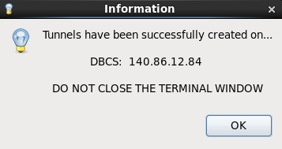

* Click OK on the dialog box to clear it.

**Note:** Do not close the terminal window that you used to run the SSH Configuration script. Closing the terminal window will shut down the background SSH tunnel processes. If you accidentally shut the terminal window, you can start over again at step 1.6.2 and run the script again. You might want to minimize this terminal window until you need to stop the tunnels.

* Examine the script to view and understand the commands used to start the tunnels.
* Type gedit mysshin the terminal window

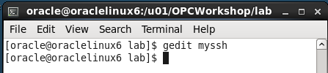

Notice under the **Host AlphaDBCS** section of the configuration file that the DBCS IP address has been inserted in 5 areas defining LocalForward ports (1526, 443, 4848, and 5500). Which correspond to host direct access, MySQL, APEX, DB Monitor, Glassfish, and Enterprise Manager. These ports can now be accessed locally using “localhost” in connection information or URLs.

**Tunneling Script Example:**

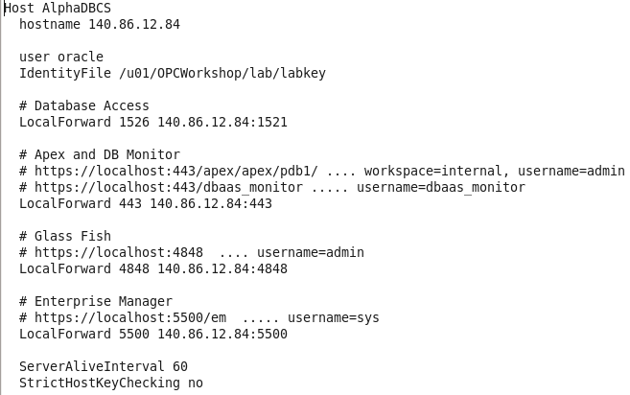

* Close the edit session.
* Type ps -ef | grep DBCS to see the background session created.

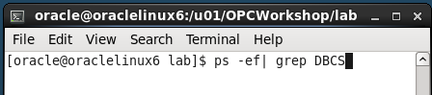

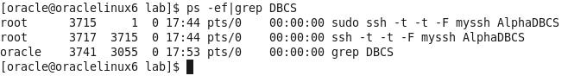

#### Explore DB image via SSH

In the previous step, you started SSH tunnels in the background for access to development tools and the browser. In this step we will demonstrate how to do an explicit SSH connection to your DB cloud server.

* Enter the below command in the same terminal window you ran the setssh.sh script, using the Public IP address of your DBCS cloud instance.
* $ ssh -o StrictHostKeyChecking=no -i ./labkey oracle@<**your-DB-Public-IP**>

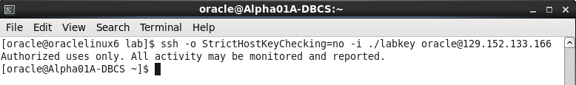

After successfully connecting to Alpha01A-DBCS you can browse the image.

* Issue a df command to see mounted disks and existing space.
* $ df -h

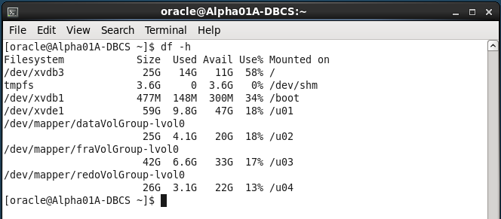

* View the Database environment variables.
* $ env | grep ORA

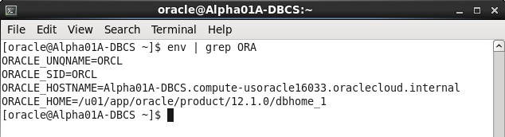

* Change directories to the Oracle Home and list the directories.
* $ cd $ORACLE_HOME
* $ ls

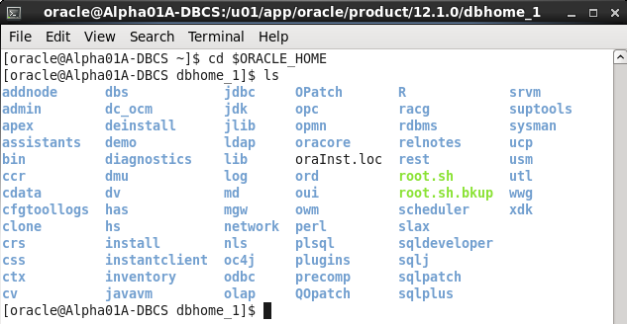

Type exit once to close the session.

$ exit

**NOTE:** By typing exit once, you are exiting the Cloud DBCS Service SSH session. If you are running commands in the same window you started the SSH tunnel scrip in and you type exit twice you will exit the terminal window and you will terminate the SSH tunnels. Do not exit the Terminal window, these SSH Tunnels will be used during the remainder of the lab. Feel free to minimize the SSH Tunnel terminal and start a new one to avoid accidentally closing the tunnels.

#### Access the Compute Cloud Service and open SSH ports for access.

**NOTE:** For any of the URLs mentioned in this section you can also use the predefined browser links. If blocked ports on the network cause an issue loading any of these consoles, the predefined browser links will help by routing the traffic through the SSH tunnel that should already be open:

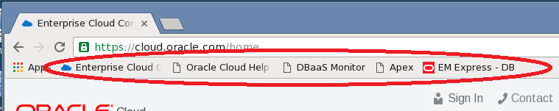

To gain access to the various consoles used by the Database Cloud Service you have two options. You can open up the port on which the monitor is listening, or you can create an SSH tunnel to the specific server/port combinations as needed. We have already created the SSH tunnels and those will be used to access the consoles we need for this lab.

In this step you will open the port 443 on the VM using a pre-created access rule and protocol definition.

* Return to your Cloud.oracle.com session on the Google browser. If you’ve logged out for any reason, log back into the cloud account using the details at the start of the lab.
* Click the header menu in the upper left next to Oracle Cloud My Services and choose the Compute Cloud console



* Click on Compute Cloud Service Console menu item

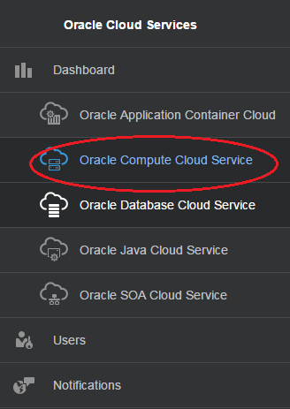

* Verify that you’re on the correct site and that the Alpha01A-DBCS and Alpha01B-DBCS instance are visible.

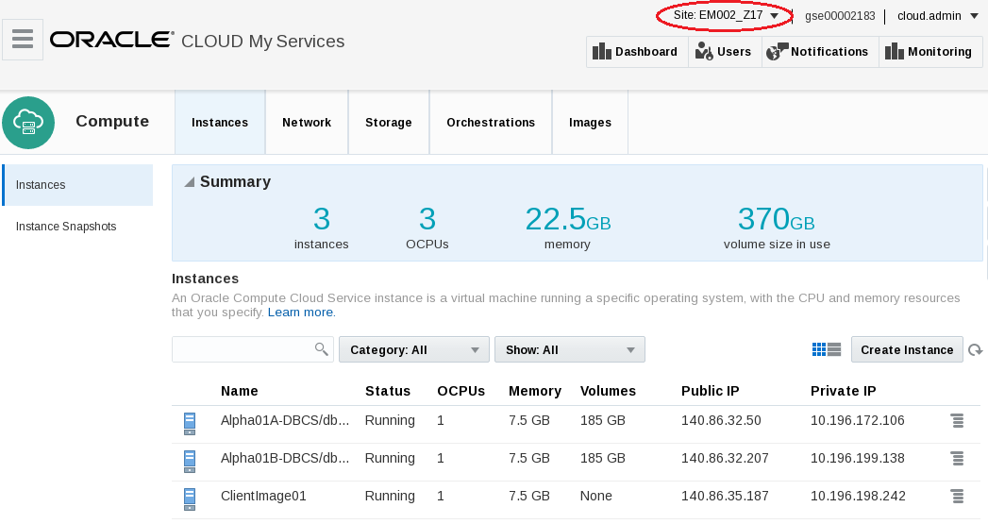

* From the top menu bar click on Network tab.

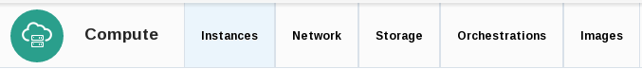

The Network section will allow you to manage security access, IP networking, and SSH information. There can be many entries so we’ll filter out what we’re looking for.

* With the Security > Security Rules section selected, type httpssl into the search box and hit enter or click the magnifying glass icon.

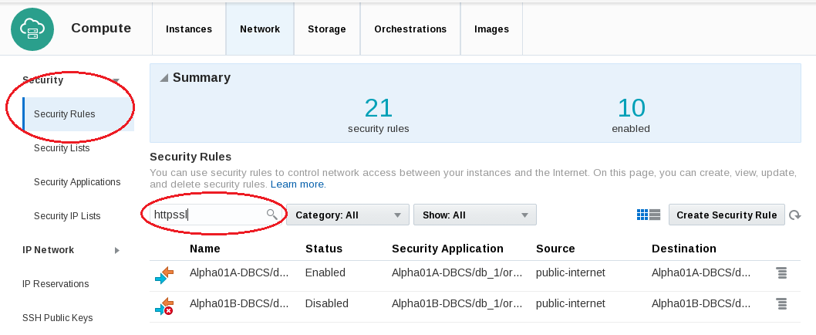

**Note:** If you can’t see the particular rule clearly, widen your browser screen or click on the table icon to change the view.

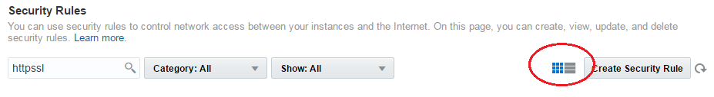

* For each instance there is an httpssl rule called ‘ora_p2_httpssl’.
* To change the rule for the Alpha01A-DBCS instance click on the hamburger menu  or on the colored arrows and select Update

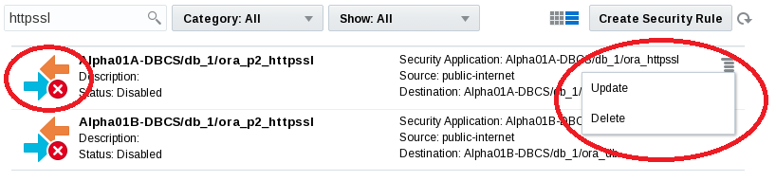

* Change Status to Enabled and click Update

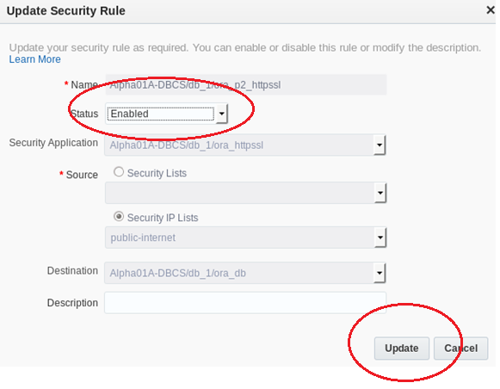

* Notice the status change for the ora_p2_httpssl Access rule to Enabled. The port is now open and can be accessed without the tunnels if necessary.

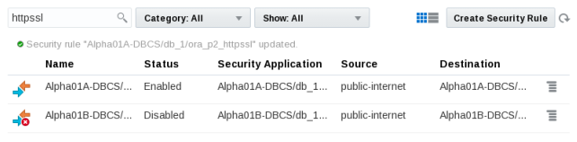

* Navigate back to the Database Cloud Service Console by clicking the header icon and selecting Database Cloud Service.



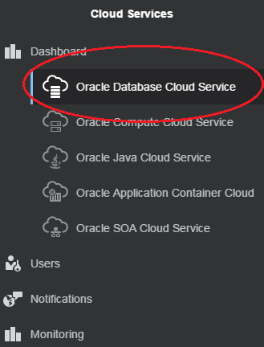

* For the Alpha01A-DBCS instance click the hamburger menu  and select Open DBaaS Monitor Console.

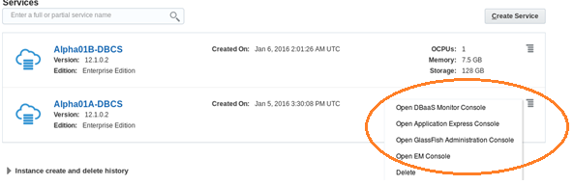

* You will likely get a security warning, click ADVANCED followed by Proceed to <your IP Address> (unsafe)

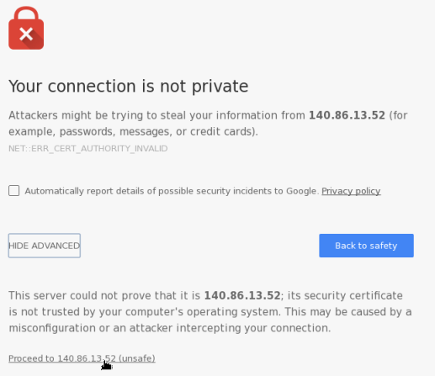

* Login to the DBaaS monitor

|  |  |
| --- | --- |
| **User Name:** | dbaas_monitor |
| **Password:** | Alpha2014_ |

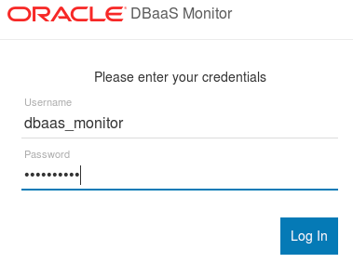

* Once connected to the Database Monitor Console, feel free to explore the various screens. Click on the header items to familiarize yourself with DBaaS monitor.
* Logout when finished

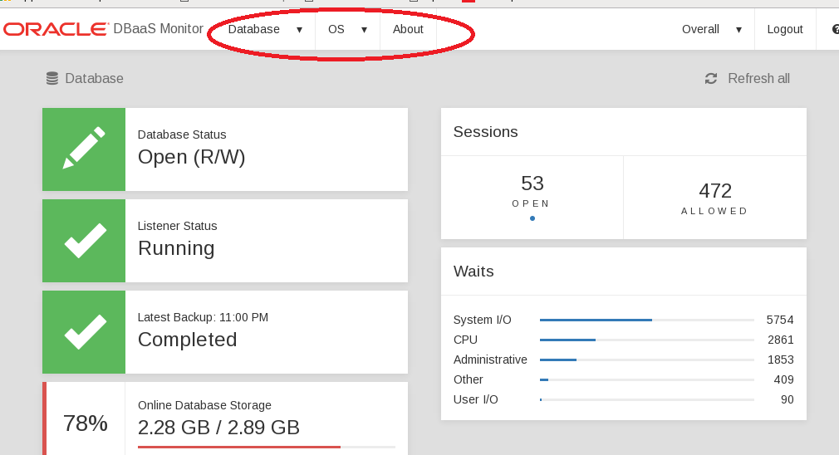

#### Access Enterprise Manager DB Express

* On the browser, open a new tab and enter the following URL to access the EM Express page. The first time the URL is used, it can take a minute for the console to load.

Note: The setssh.sh script that you ran earlier in this lab created the ssh tunnel which routes all traffic over localhost:5500 to the database cloud service.

* https://localhost:5500/em

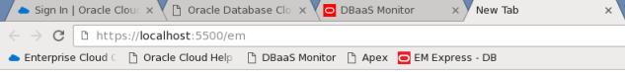

* If you get a security warning, click ADVANCED followed by Proceed to localhost (unsafe)

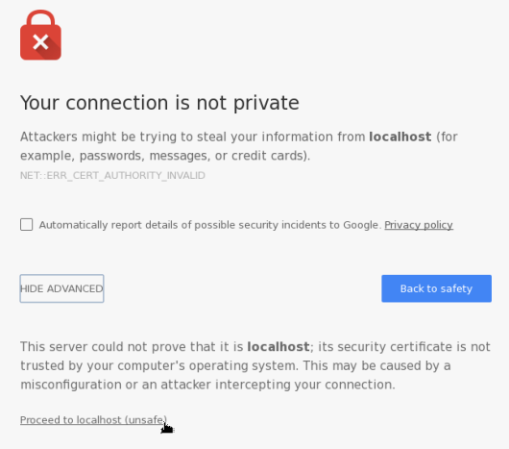

* On the EM login page enter the following and click on Login:

|  |  |
| --- | --- |
| **User Name:** | sys |
| **Password:** | Alpha2014_ |
| **Checkbox:** | “as sysdba” |

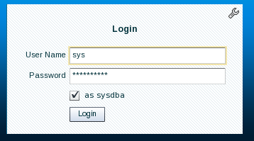

* Click on different items on the Enterprise Manager console to get familiar with its capabilities.
* Logout when finished.

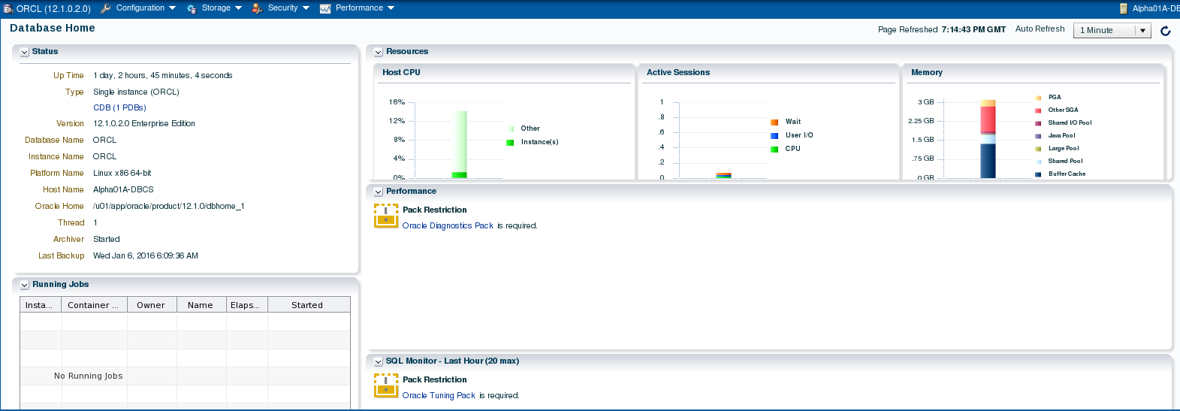

#### Access Apex Monitor

* Enter the following URL into a browser window to access the Apex console (click to add a security exception if necessary).

Note: All traffic to the default https port (443) on local host is also routed through the SSH tunnel to the database cloud service.

* https://localhost/apex/pdb1/

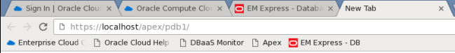

* If you get a security warning, click ADVANCED followed by Proceed to localhost (unsafe)



* Once the Apex login window is displayed, enter the following and click on Sign In:

|  |  |
| --- | --- |
| **Workspace:** | internal |
| **Username:** | ADMIN |
| **Password:** | Alpha2014_ |

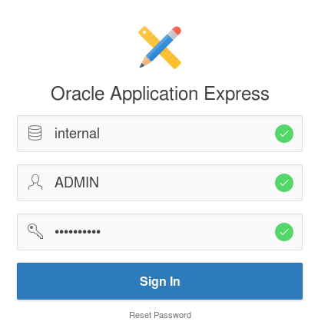

* You are now connected to Apex. Feel free to explore the various menu options. The last lab in this workshop will walk you through the creation of a simple application.
* Log out of APEX when you are finished.

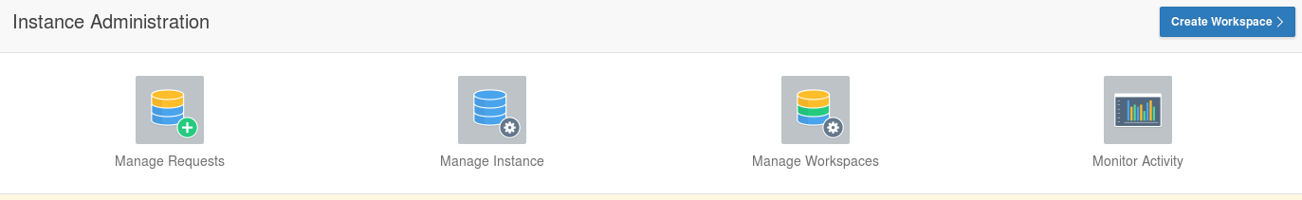

* This concludes the first lab, Overview of DBCS. Proceed to the next lab when ready.

# Cloud Migration

### Introduction

In this lab you will explore some common methods for moving data from on premise to the cloud. There are multiple options for solving this data movement challenge. In this lab we will use SQL*Developer and command line tools to clone and move a pluggable database from an on premise database (in the provided Virtual Machine) to a cloud database. We will also use standard Oracle Data Pump tools to export a schema from the on premise database, and then import that data to a cloud database in a new schema. The final exercise will use the SQL Developer cart feature to quickly move data from the local database to the cloud using only the privileges of a normal schema owner.

### Objectives

* Clone, unplug, transfer, and plug the AlphaPDB pluggable database using SQL Developer.
* Export and import a schema using SQL Developer to execute Oracle Data Pump jobs.
* Export and import a small collection of tables using SQL Developer.

### System Requirements

* VNC Viewer for connection to client system
* Successful completion of Section 1: Database Cloud Service Overview lab.
* The SSH tunnels must be active in a terminal window in the client system

### Cloud Migration Using Pluggable Databases

In this section of the lab we will prepare the on premise environment and create connections. Then we’ll clone the database. We’ll create SSH connections to the cloud instance and finally we’ll copy the clone to the public cloud using Oracle SQL Developer. Once the database has been cloned we will patch the instance to bring it up to date with the Cloud Container database. We will verify successful patching and login in to the newly migrated Database instance.

#### Configure the Environment

* From the VNC Session desktop, locate and double-click on the StartDB icon. It will take a minute for the Database to fully start. Once started, the Terminal Log Window will automatically close.

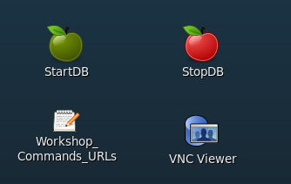

* From the VNC Session desktop, locate and double-click on the SQL Developer icon. We will use SQL Developer to connect to the on premise database.

**NOTE:** The first time SQL Developer is brought up, it may a few minutes to start up.

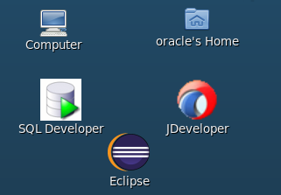

* Double-click the On-premise folder or click on the plus sign next the folder to expand the list of database connections. Please note the pre-configured connections to the on-premise database, Alpha – PDB, sys- AlphaPDB and sys-CDB.

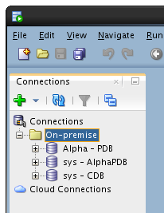

**Alpha - PDB**

This is a normal database connection to the *alpha* schema inside the Alpha pluggable database.

**sys - AlphaPDB**

Privileged *sys* account in the Alpha pluggable database.

**sys - CDB**

Privileged *sys* account for the on-premise container database.

* Select the View -> DBA menu option from the top dropdown menu to open up the DBA navigator panel.

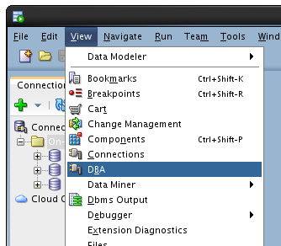

* On the DBA panel, click the green plus icon to create a new connection.

**Note**: you can also right-click on the green plus sign under Connections and select Add Connection.

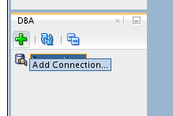

* Select the sys - CDB connection and click OK.

**Note:** “sys – CDB” is the on premise database located on the virtual client Image.

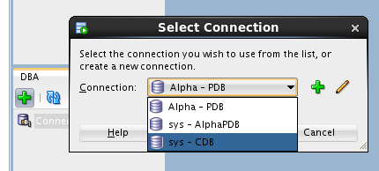

* Expand the sys - CDB connection by double clicking or by clicking on the plus sign, then expand the Container Database tree item. Click on the ALPHAPDB pluggable database item and view the details for the pluggable database.

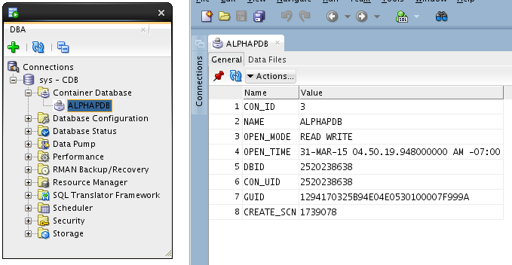

#### Clone the ALPHAPDB

* In the DBA Navigator panel, right click on the ALPHAPDB pluggable database and select the Clone Pluggable Database… menu option.

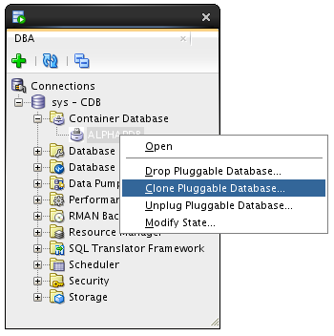

* Enter the following: Database Name: **ALPHACLONE**

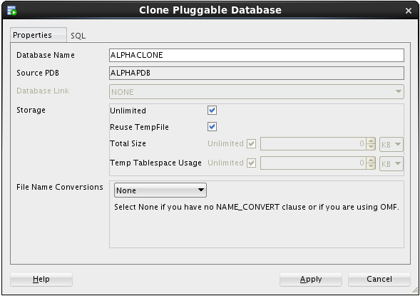

* Select Custom Names from the File Name Conversions section and review the Source File names. Note the name "**/AlphaPDB/**" for the directory of the source file names. For a successful cloning operation, we must create new target files that are different than the source files.

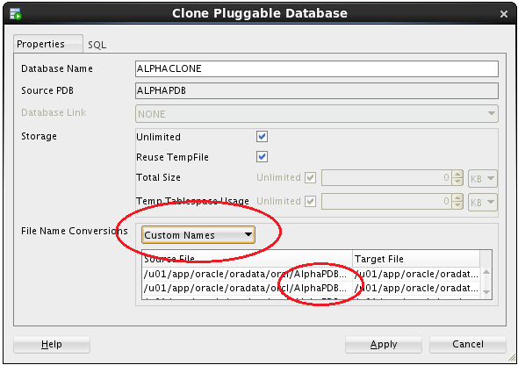

**Note**: At this point we could manually change all the target files to point to a different directory, but following are directions for an easier way to do this.

* Select Custom Expressions from the File Name Conversions drop down.
* Click the green plus icon
* Enter the source directory portion we want to change, followed by the target for the new files. Use the information from the table below being sure to use the indicated upper and lower case letters:

|  |  |
| --- | --- |
| **Source File Pattern** | AlphaPDB |
| **Target File Pattern** | AlphaClone |

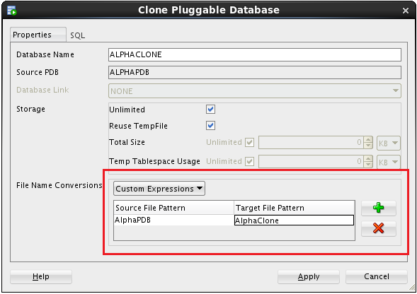

* Review the SQL statement by clicking on the SQL tab - note the **FILE_NAME_CONVERT** clause mapping the existing files to new files in a new directory.
* Click the Apply button.

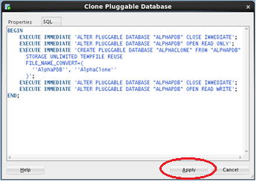

* SQL Developer shows the action in-progress message for roughly 1-2 minutes followed by a success message.
* Click OK on the success message.

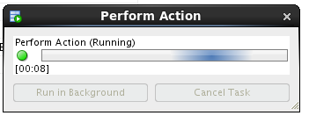 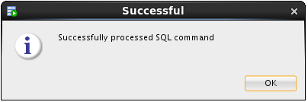

* Click on the ALPHACLONE database in the DBA navigator to see the status of the database.

**Note**: the cloned database shows an **OPEN_MODE** of **MOUNTED** indicating the database is plugged-in but is not open for access.

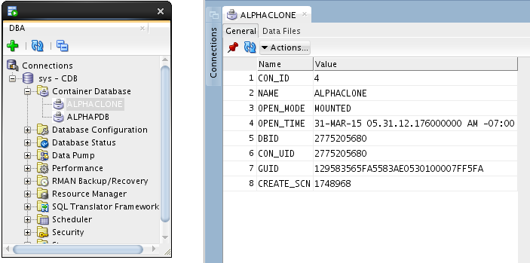

* Click on the Data Files tab for the ALPHACLONE to review the data files created during the cloning operation.

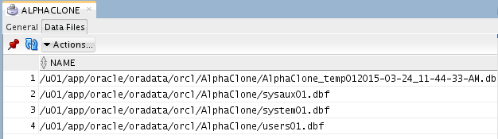

#### Create SSH Host

In this section you will create SSH and SYS database cloud connections.

In the following steps you will record the IP addresses of the Virtual Machine on which the cloud service runs and configure SSH connectivity to Alpha01A-DBCS. Then you will access the different monitoring, configuration, and development consoles available on Oracle Database Cloud Service.

* If you haven’t already noted down from the last lab, determine the Public IP address of Alpha01A-DBCS as we’ll be using that IP to set up our SSH connection for the data migration exercises.
* Open a browser and login to cloud.oracle.com using the credentials provided by your instructor.
* Click on the hamburger menu at the top right of the Database service section in the Dashboard and choose “**Open Service Console**”

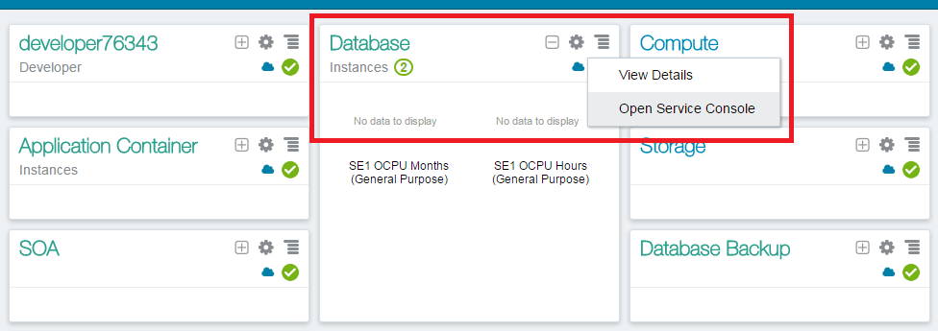

* Click on Alpha01A-DBCS from the list of Database Instances

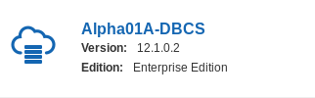

* Note the Public IP address of Alpha01A-DBCS. The IP address for your lab will be different than the one in the below screenshot.

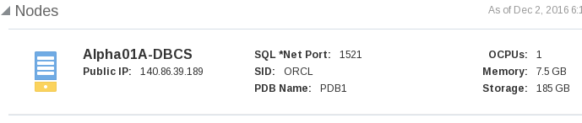

* Now we can setup an SSH host connection to the Database Cloud Service instance.
* Return to SQL Developer. From the top menu select View -> SSH to display SSH hosts panel on the left.

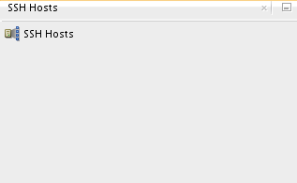

* Right click on SSH Hosts and select New SSH Host.

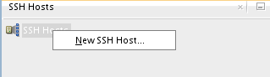

Enter the following information to configure the SSH connection to the DBCS instance

|  |  |
| --- | --- |
| **Name** | Alpha01A-DBCS |
| **Host** | Public IP of Alpha01A-DBCS |
| **Username** | oracle |

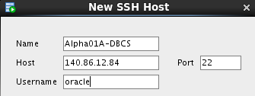

* Select Use key file and click Browse... Select file /u01/OPCWorkshop/lab/labkey and click Open.

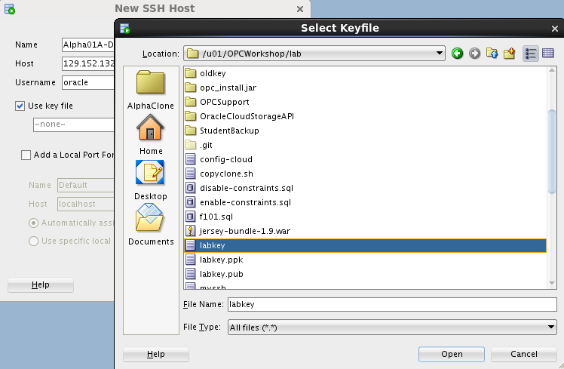

* Click Add a Local Port Forward and enter the following values:

|  |  |
| --- | --- |
| **Name** | Database |
| **Host** | Public IP of Alpha01A-DBCS |
| **Use specific local port** | 1530 |

**NOTE**: We are using port 1530 since 1521 is already in use for our local database.

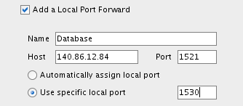

* Verify the configuration and click OK
* Click the green plus sign  in the Connections window to create a new SQL Developer connection to the Public Cloud Database SYS schema